

MINUTES OF COMMITTEE MEETING – 18TH November 2023

The meeting was held at Costa, Woolley Edge Southbound

Present: Lesley Sleigh (President) Mick Bennett (Treasurer), Steve Hurley, Di Forbes, John Wade, Paul Goldthorpe, Martyn Eastwood, Andy Hartley, and Julie Aylward (Secretary)

The meeting chair was absent so S Hurley took the chair (R Hall arrived later)

The Secretary handed out an Agenda and it was agreed and adopted unanimously.

The meeting was brought to order at 11:10.

1. Apologies

M Byard and Andrew Beever

2. Declarations of Interest

The following stated that they are also members of the West Riding Omnibus Preservation Society: Steve Hurley, Mick Bennett, Andy Hartley and Richard Hall

3. Minutes of Previous Meeting

Paul Goldthorpe pointed out that his name is missing from the roll call at the last meeting. It was agreed that this should be added. It was proposed by Andy Hartley and seconded by Di Forbes that they are a true and accurate record of that meeting.

4. Matters Arising

There were no matters arising that will not been dealt with elsewhere.

5. Treasurer’s Report

The Treasurer reported that the financial statement was the same as that presented to the Members’ meeting on 15th November (to be attached – Appendix A).

The Secretary read out a memo from Mark Byard regarding high interest deposit accounts (attached – Appendix B). Mick Bennett reported that he had visited Lloyds bank in Wakefield but that he had been effectively “fobbed off”, possibly due to the inexperience of the person to whom he spoke. It was agreed to authorise the Treasurer and Andrew Beever to make an appointment with a specialist adviser at Lloyds bank to see what they could offer.

6. Health & Safety and Risk assessments

The Health & Safety officer was not present and had not sent a report.

Hywema inspection and test

Mick Bennett reported that Bill has not actually been doing formal inspections of the Hywema lifts as he is not qualified to do this. Mick Bennett stated that the existing lifts, which belong to Steve Hurley, are not suitable for use with several of the vehicles in the museum and require a “pre-lift” to be able to use them. He suggested that we should acquire a more modern set, either new or re-manufactured ones, which would come with a service/maintenance contract and suitable training for users. After much discussion, the following points were agreed:
- A prohibition of using the existing lifts, starting now
- Steve Hurley to arrange for the existing lifts to be sold or removed from site before the May 2024 open day
- Mick Bennett to spec new set, Di Forbes and John Wade to get quotation for new/re-furbed replacement set
- Di Forbes and John Wade to get approval from all committee members before final approval at next meeting.
- If replacement set arrive at museum before removal of existing, Trust will pay for their removal
Action – Di Forbes, Mick Bennett and John Wade

Electrical Safety Policy

The Secretary had previously submitted a draft policy but the committee had rejected it on the grounds that the document was too long at six pages, and asked for two separate documents, one for Fixed Wire Testing and one for Portable Appliance Testing. The Secretary explained that much of the document covers definitions and that splitting the six page document would result in two five page documents. Mick Bennett said that, as we do not actually employ anyone, a comprehensive policy is not required. John Wade explained that the Trust has a Duty of Care to anyone entering the premises and that the Trustees would be liable in law for any failings resulting injury or harm to anyone. Acceptance of the document was proposed by Steve Hurley, seconded by Andy Hartley and was approved unanimously for immediate implementation. This is attached as Appendix C. It is to be added to the website library. Action - Secretary

7. Committee Vacancies

There is still a vacancy for a committee member. This will be an ongoing agenda item until the post is filled.

8. Governance

Following the discussions at the last meeting, there was discussion about the order of priority when deciding the allocation of storage licences as defined in the Trust constitution. Changes to the constitution can only be made at an AGM. After much discussion, it was decided to make the following proposal to the 2024 AGM: “For the purpose of storage licence allocation only, the West Riding Omnibus Preservation Society shall be deemed to be a full member of the Trust”.

9. Storage Licence Ts & Cs Review

There was much discussion about the re-charging of building operating expenses to the licensees. The cost of operating the building during the year ending 1st October 2022 was £4646 whilst licence income was £4650. This is to be added to the agenda for all future committee meetings for rolling review. Action - Secretary

10. Museum Building Report

This item is deferred to the next meeting.

11. Website Report

The Secretary reported that she is in the process of adding Trust minutes to the website. The buttons in the Members’ Area have been added but she is waiting for the former Secretary providing the minutes. Action – Andy Beever

12. Facebook Report

Andy Hartley reported that there are now 2210 followers and that there is a good level of activity.

13. Archive Report

It was reported that the sorting and tidying of the photograph stock is ongoing and that a list has been produced. Action – Paul Goldthorpe

14. Membership Report

The Secretary reported that so far, fifteen members have renewed

15. Outreach Team Report

Nothing to report

16. Correspondence Received

No correspondence received.

17. Strategic Development Officer Report

The Strategic Development Officer reported that she has had discussions with Lee Carnley of Vickers Carnley, a prominent commercial estate agent in Wakefield, about the possible problems that land contamination may present to the Trust in the future should the Trust acquire the land off Ings Road. He explained that there is a model for the dissipation of non-radioactive contamination and there would not be a problem after 10 years after the contamination is sealed.

He also offered to make initial professional contact with the owners of the car park without charge.

Mr. Carnley had suggested that a formal offer of £175,000 would be a good start. Mick Bennett asked where the money would come from for this and the Secretary said that the existing premises could be mortgaged to provide the funds as it had been valued at around £600,000. Mick then said that if it was to go ahead, it would be a bad idea to mortgage the existing building.

The Secretary agreed to provide the latest estimates for the whole proposal to the next Committee meeting.

18. Trust Events 2023

Nothing to report

19. Trust Events 2024

- Spring Running Day – Sunday 19th May 2024
- Batley Community Bus Day – Sunday 7th July 2024
- Autumn Running Day – Sunday 22nd September 2024
- Booklet format and price

There is nothing to report on these items at this stage

20. External Events 2024

Nothing to report

21. Any Other Business

There was discussion about the acquisition of debit/debit card reader. Di Forbes agreed to look into the options and to report to the next meeting.

The committee members present all gave permission to the Trust to give access to all other committee members to share their contact details, phone numbers and e-mail addresses for the purpose of facilitating Trust business. The Secretary is to distribute permission forms for GDPR compliance. Action - Secretary

John Wade raised the lack of a bench/vice/pillar drill at the museum. This is to be added to the agenda for the next meeting.

John Wade suggested that we should acquire a welfare/amenities cabin. This is to be added to the agenda for the next meeting.

21. Next Meeting

The next meeting will be held at 7pm on Monday 12th February 2024. A new venue is to be arranged but if one cannot be found, the meeting will be held at Costa, Woolley Edge southbound.

22. Close

The meeting closed at 14:08.
APPENDIX A: Financial Report

DEWSBURY BUS MUSEUM
WEST RIDING OMNIBUS MUSEUM TRUST NOVEMBER 2023 FINANCE STATEMENT
Opening Balance |  |  |  |  |  |  |  |  |  |  |  | 9,442.12
 |  |  |  |  |  |  |  |  |  | Receipts | Payments
Fees Received
 |  | 01/11/2023 |  |  | A. Tindall |  |  |  |  | 60.00
 |  | 01/11/2023 |  |  | J. Ellis |  |  |  |  | 60.00
 |  | 01/11/2023 |  |  | P. Goldthorpe |  |  |  |  | 60.00
 |  | 01/11/2023 |  |  | M. Bennett |  |  |  |  | 60.00
 |  | 01/11/2023 |  |  | R. Hall |  |  |  |  | 60.00
 |  | 08/11/2023 |  |  | S. Turner |  |  |  |  | 60.00
 |  | 15/11/2023 |  |  | Di Forbes |  |  | Memberships Subs |  | 20.00
 |  | 20/11/2023 |  |  | 63434572 |  |  | Kirklees Business Rates |  |  | 195.00
 |  | 22/11/2023 |  |  | 500353 |  |  | Memberships Subs |  | 145.00
 |  | 22/11/2023 |  |  | 500353 |  |  | Memb's Subs Stall Fees |  | 425.00
 |  | 27/11/2023 |  |  | A Beever |  |  | Memb's Subs AB MB IH |  | 60.00
 |  |  |  |  |  |  |  | WROPS Donation |  | 5.00
 | Total Receipts - Payments |  |  |  |  |  |  |  |  | 1,015.00 | 195.00
Closing Balance |  |  |  |  |  |  |  |  |  |  |  | 10,262.12

APPENDIX B

Dear all

Following he meeting last night, I offered to take a look at Charitable Savings accounts as some of the views expressed in the meeting were that it was "hard" to identify such accounts.

This following list is not exhaustive, but is merely a sample of what I have found this morning. There are literally upwards of 50 different types of account I identified all of which are covered by the £85K government financial authority guarantee.

Most financial institutions offer dedicated savings accounts to Charitable organisations, including LLoyds Bank where we hold our accounts.

Reliance Bank 1 Year fixed deposit 5.50%
HTB 1 Year Bond 5.15%
Redwood 90 day notice 4.30%
Dudley Building Society 30 day notice 4.00%
Lloyds Bank 12 month Bond 3.60%

Given we have such a healthy balance in our reserve fund, and with rates on offer around 5%, we are essentially throwing money away by not taking immediate action to move some, if not all our reserves, across to other accounts and/or other financial institutions.

Regards Mark

APPENDIX C

WEST RIDING OMNIBUS MUSEUM TRUST

Electrical Safety and Portable Appliance Testing

1.0 Statement of Policy:

The Electricity at Work Regulations 1989 came in to force on 1st April 1990. The Regulations are made under the Health & Safety at Work Act 1974 and require precautions to be taken to prevent death or personal injury from electricity in work activities. The Regulations impose responsibilities on the employer and employees to conform to these regulations in every respect. Whilst the Trust currently does not have any employees, the regulations also impose a duty of care to visitors to any premises so this policy shall apply to all members, visitors, contractors and any future employees. The testing of electrical equipment is an inherent part of compliance with these regulations, therefore, the Institute of Electrical Engineers (I.E.E.) have issued a Code of Practice for in-service inspection and testing of Electrical Equipment (called the I.E.E. Code of Practice).

The Trust shall take all reasonable steps to ensure that all portable appliances are tested in accordance with the relevant I.E.E. Code of Practice, and to facilitate this shall provide all training and equipment necessary to carry out tests and provide a satisfactory means of recording data.

2.0 Definition of Portable or Transportable Appliances:

There is no universally accepted definition of what is meant by portable or transportable electrical equipment. However, in this policy it means equipment that is not part of a fixed installation, but is intended to be connected to a fixed installation, or a generator, by means of a flexible cable and either a plug and socket, or a spur box, or similar means. This includes equipment that is either hand-held or hand-operated while connected to the supply, intended to be moved while connected to the supply, or likely to be moved while connected to the supply. The electrical supply to the equipment is assumed to be at a voltage that can give a fatal electrical shock to a person, i.e. more than 50 V ac or 120 V dc.

Examples of portable equipment include: tools and extension leads in the construction industry (high-risk); grinders and hand lamps in general manufacturing (medium-risk); and floor cleaners and metal-bodied kettles in offices (medium-risk). Extension leads, plugs and sockets, and cord sets that supply portable equipment, are classified as portable equipment because they operate in the same environment and are subject to the same use as the equipment they serve.

Note: The word ‘portable’ is used subsequently to mean both portable and transportable.

Only equipment fitted with a plug, rated between 110 and 500 volts ac, and allowing disconnection from the electrical supply without the use of a tool, will fall within the scope of this Portable Appliance Testing policy.

The Trust will ensure that the guidelines stated in HS(G) 107: 2013 ‘Maintaining portable and transportable electrical equipment’ are followed.

Table 1 (below) from HS(G) 107: 2013 sets out the suggested frequency of formal visual inspections, combined inspections and electrical tests for portable and transportable electrical equipment. It gives suggested starting intervals when implementing a maintenance programme. Where one figure is given, this is a guide for anticipated average use conditions; more demanding conditions of use will require more frequent formal visual inspections, and/or combined inspections and tests. Where a range is shown, the small interval is for more demanding conditions of use and the longer interval is for less demanding ones. The Health & Safety Officer, with appropriate advice where necessary, will assess the conditions affecting equipment, which may lead to potential damage and/or deterioration and will determine the maintenance regime.

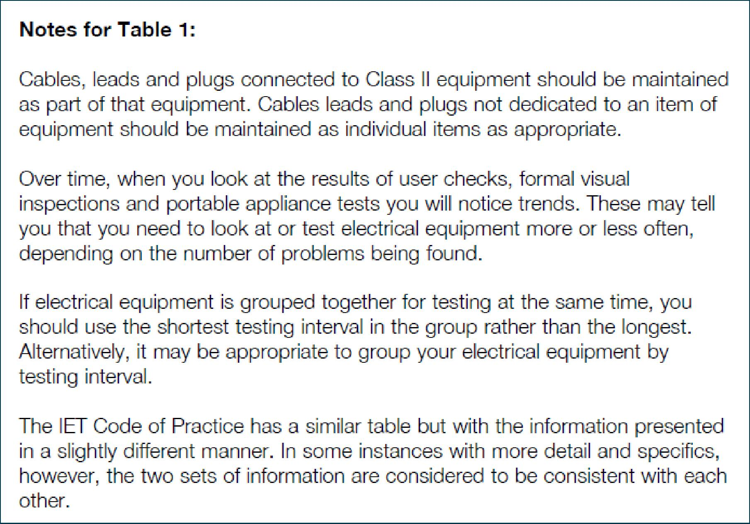
Table 1: Suggested initial maintenance intervals

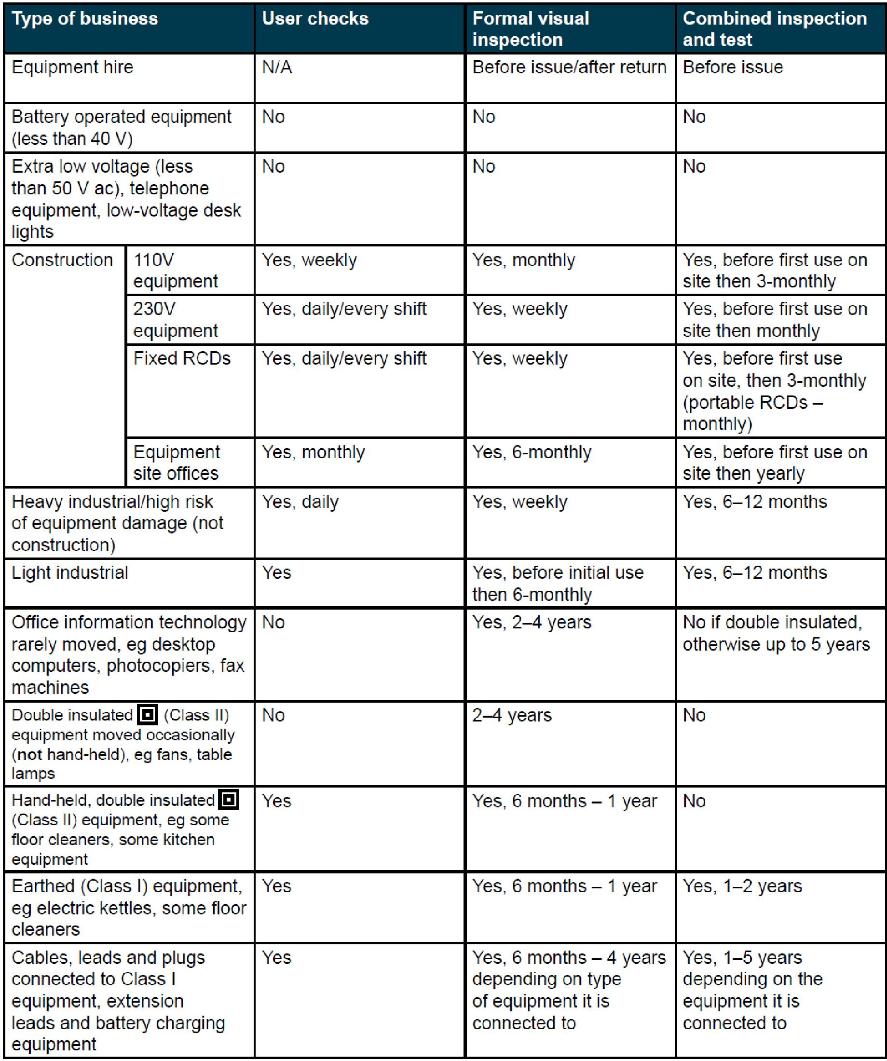

All equipment not included in this definition must be identified by the equipment user and brought to the attention of the Health & Safety Officer for inclusion in the Fixed Wiring Testing process.
3.0 Organisation and responsibilities:

3.1 All Trustees shall:

- Be responsible for ensuring that all portable electrical appliances in their charge are examined and tested in accordance with the Regulations and withdrawn from use if found to be unsafe.

- Ensure that the risks to personnel are assessed and records of inspections and tests are maintained.

- Be responsible for ensuring that anyone appointed to test portable electrical appliances are competent to undertake the duties imposed upon them.

The Trust will ensure that the guidelines stated in INDG236(rev3), published 09/13 ‘Maintaining portable electric equipment in low-risk environments’ are followed.

Electrical equipment must be maintained if it can cause danger, but the law does not say how this must be done or how often. The level of maintenance needed will vary according to the risk of an item becoming faulty, and how the equipment is constructed. The following will be considered:

- the increased risk if the equipment isn’t used correctly, isn’t suitable for the job, or is used in a harsh environment; and

- if the item is not double insulated, for example some kettles are earthed but some pieces of hand-held equipment, such as hairdryers, are usually double insulated.

This includes any electrical equipment used on Trust premises, whether it is
privately owned or supplied by the Trust. There is a joint responsibility to maintain any equipment used by anyone that is either leased (e.g. a photocopier) or provided by a contractor (but not equipment both provided and used by a contractor).

Periodic checks will be carried out if any work needs doing. How this is done depends on the type of equipment.

3.2 The Health and Safety Officer Shall:

- Be the first point of contact for all electrical matters

- Be responsible for the maintenance of a register of portable equipment and shall remove test expired items pending re-testing

- Arrange for the periodic Fixed Wire Testing to take place and to arrange any corrective work required

4.0 Competency of Appliance Testers:

Members selected to undertake testing duties will be made fully aware of their responsibilities and of the consequences involved should they fail to carry out their duties in a prescribed manner. Training is required for all members who undertake to carry out the testing of portable electrical appliances.

5.0 All Members:

The Trust undertakes to inform all equipment users of their duties under the Regulations and provide appropriate training where required. It is the duty of everyone who use any electrical equipment to ensure that it is free from any visible damage and supports a valid test label. Where any visible damage is present then the equipment must be taken out of use until inspected by a competent person and any defects which may be dangerous rectified. If the equipment does not have a valid test label then the user shall inform the Health & Safety Officer who will then arrange for the item to be tested.

Anyone wishing to bring their own equipment to site must first inform the Health & Safety Officer and make arrangements to have that equipment tested (if it does not already carry a valid certificate of inspection). A record of the appliance must be made and it must be identified as personal equipment. Should the equipment be faulty then it shall be removed from the site.

Any breach of these duties by a member of staff may lead to disciplinary action by the Trust.

6.0 Visitors:

Equipment belonging to and used by persons visiting Trust premises must be in an electrically safe condition. The Trust reserves the right to prohibit the use of any electrical equipment brought onto the premises by a visitor which does not appear to meet this requirement.

7.0 Contractors:

Equipment belonging to and used by contractors of the Trust must have a valid test certificate or label attached which is available for inspection upon request by any Trust member. If the equipment does not possess relevant safety documentation it will not be allowed onto the Trust’s premises.

8.0 Fixed Wire Testing:

Fixed wire testing is a required to ensure compliance with legal requirements to ensure the building’s electrical system is safe, maintained and tested by competent, qualified individuals. This will ensure the provision of a safe and hazard-free environment for members, visitors and the public at large.

The testing checks the condition of the electrical installation against the UK standard for the safety of electrical installations, BS 7671. Each circuit’s cable and accessories will be inspected for visual damage and wear and tear, followed by a series of tests to verify the wiring is safe and the circuit is wired correctly.

It will be carried out by a competent qualified contractor at a time not exceeding five years from the date of the last inspection. Any defects found during the testing will require that part of the electrical system to be isolated from use and will be corrected without delay.

Following the electrical testing and inspection, an Electrical Condition Report (EICR) for the fixed wire test will be issued by the contractor and this shall be displayed in the premises.

A satisfactory EICR issued by a competent and qualified individual confirms compliance with the Health and Safety at Work Act 1974 and the Electricity at Work Regulations 1989.

